**Html Table**

**Theory Assignment 3**

**Q.1 Explain the structure of an HTML table and the purpose of each of the following elements: <table>, <tr>, <th>, <td>, and <thead>.**

**Ans:** An HTML table is used to organize data in rows and columns. Here's a breakdown of its structure and the role of each element:

* <Table>
  + This is the main container that defines the entire table.
  + All rows, header and data cells are placed inside this tag
* <tr> (Table Row)
  + Represent a single row in the table
  + Each row is made up of header cell and data cell.
* <th> (Table Header)
  + Used inside a <tr> to define a header cell.
  + Header cell are usually bold and centered by default.
  + They describe the label or title for a column or row.
* <td> (Table Data)
  + Represents a standard data cell in the table.
  + It holds the actual content (like text, numbers, links, etc.) of the table.
* <thead> (Table Head)
  + A sectioning element used to group all header rows.
  + Typically contains one or more <tr> elements with <th> cells.

**Q.2 What is the difference between colspan and rowspan in tables? Provide examples.**

**Ans:** The main difference between of colspan and rowspan is colspan merge columns horizontally and rowspan merges rows vertically.

Example:

**Colspan**  
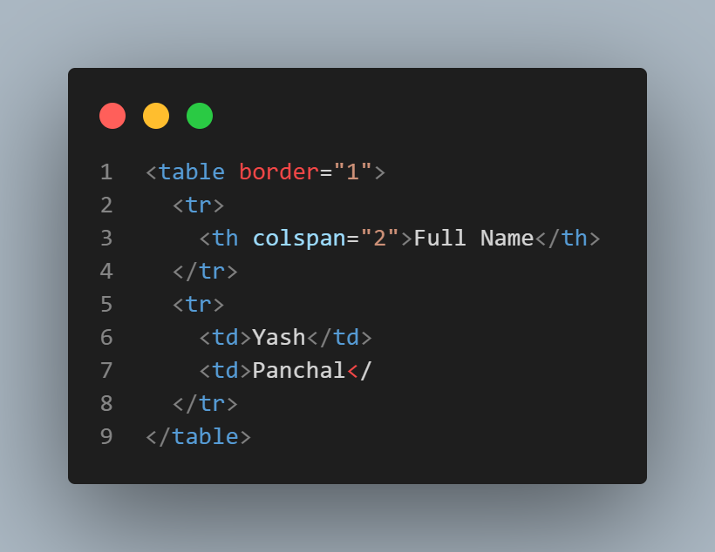

**Output:**

|  |  |
| --- | --- |
| Full Name | |
| Yash | Panchal |

**Rowspan**

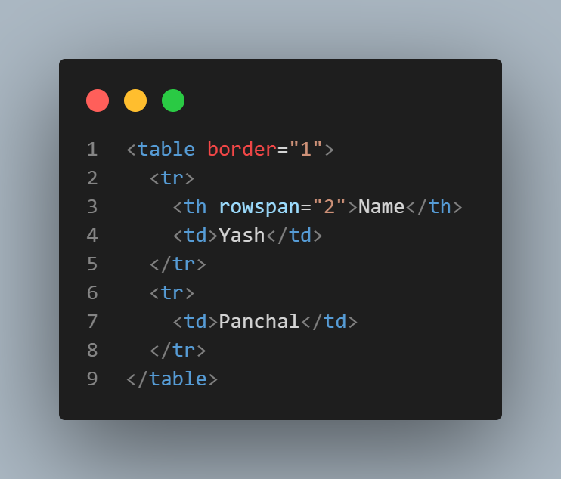

|  |  |
| --- | --- |
| Name | Yash |
| Panchal |

**Output:**

**Q.3 Why should tables be used sparingly for layout purposes? What is a better alternative?**

**Ans:**